6.4 Fancy Yarns
Fancy yarns are special products of spinning, twisting, wrapping, texturing and knitting, etc. The demand for yarns with structural and/or optical effects is due to the special aesthetic and high decorative appeal to the woven, knitted materials, and other textiles as well. Textile materials that are produced using yarns with effects find applications in normal and high fashion clothing.
Such yarns are also used for decorative textiles like
- curtains
- carpets
- ladies and children Outerwear
- Decor materials and textile fabrics in the corporate sector, as for example in the trim of a car or textile furnishing of a hotel lobby are becoming more and more important.
Fancy yarns have deliberately introduced irregular characteristics, in either diameter and bulk and/or in color, etc. as well as virtually new structures composed of fibers, yarns or other products that differentiate them from conventionally spun or multifilament yarns. New looks, structures and raw materials of fancy yarns are constantly in demand.
Components of fancy yarns can be of natural or man made fibers: staple length or continuous filaments but nowadays it appears the especially unusual structures of fancy yarns that are very desirable in designing of new textiles. There are so many different types of fancy yarns. Most of them are produced using spinning or twisting machinery that are modified or specially developed for this purpose. Some types of such yarns are produced from “fancy fiber” or “fancy slivers” used as minor components of yarns made by spinners with normal equipment, still others are made exclusively by filament yarns using adaptations of various processes as well as tape-knit fancy yarns are produced using a range of take-up rations and component yarns on a knitting machine specially designed for fancy yarn manufacture.
Different types of fancy yarns that are available are briefly described.
Marl Yarn
This is the simplest among the fancy yarns and is made by twisting two different colored yarns by doubling process. It is different from normal double yarn in the sense of texture.

Figure 1 : Structure of Marl Yarn.

The yarn structure shown in Figure 1 above clearly shows the alternation of the colors that is the primary effect of marl yarn, as well as demonstrating the plain structure, which is that of an ordinary folded yarn.
Use
These yarns are used make to good effect in discreet pinstripes for men’s suiting’s or to produce a subtly and irregularly patterned knitted fabric with a relatively simple fabric construction. They may also be used to provide a Lurex or other metallic yarn with strong support, while at the same time creating a more subtle effect.
Spiral or Corkscrew yarn
A spiral or corkscrew yarn is a plied yarn that displays a characteristic smooth spiraling of one component around the other. Figure 2 shows the basic structure, which is straightforward, except in the differing lengths of the two yarns involved, very similar to the structure of a marl yarn.

Figure 2 : Structure of Spiral or Corkscrew Yarn

Gimp Yarn
A gimp yarn is a compound yarn consisting of a twisted core with an effect yarn wrapped around it so as to produce wavy projections on its surface. This structure is shown in Figure 3.
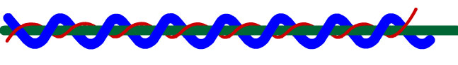
Figure 3 : Structure of Gimp Yarn

Since a binder yarn is needed to bring the stability of the structure, the yarn is produced in two stages. Two yarns of widely varying counts are plied together, thick around thin, and then reverse bound. Reverse binding removes of twist that creates the wavy profiles, since it makes the effect yarns longer than the actual length of the completed yarn. The texture properties of a gimp are clearly better than those of a spiral yarn, as apart from being different. The finer of the two gimps shows that the effect is less regular, and even perhaps less well-defined.
Diamond Yarn
A diamond yarn is produced by folding a coarse single yarn or roving with a fine yarn or filament having contrasting color using S-twist, and cabling it with a similar fine yarn using Z-twist. Multi-fold or ‘cabled’ yarns may be made by extending and varying this technique, to bring about a wide range of effects. Clearly, a true diamond yarn would show some compression effect upon the thick yarn from the thin ones, an effect which in the interests of clarity is not provided in Figure 4.
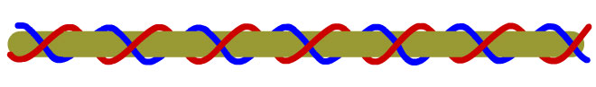
Figure 4 : Structure of Diamond Yarn

This is a yarn that can be very useful to designers looking to create subtle effects of color and texture, particularly in relatively simple fabric structures.
Boucle yarn
This types of yarns are characterized by tight loops projecting from the body of the yarn at nearly regular intervals, as shown if Figure 5. Some of these yarns are made by air-jet texturing, but most are of three-ply constructions. The three components of the yarn are the core, the effect, and the tie, or binder. The effect yarn has the loops wrapped around a core, or base yarn, and then the third ply, or binder, is wrapped over the effect ply in order to hold the loops in place. The individual plies could be filament or spun yarns. The characteristics of these yarns determine the ultimate design effect.
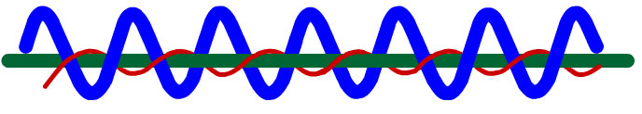
Figure 5 : Structure of Boucle Yarn

Loop Yarn
A loop yarn has core with an effect yarn wrapped around it and overfed so as to produce nearly circular projection on its surface. Figure 6 shows the structure of a loop yarn, in this case somewhat simplified by showing the core as two straight bars. In reality, the core, which for a loop yarn always consists of two yarns twisted together, which can entrap the effect yarn.
As a general rule, four yarns are involved in the construction, of which two forms the core or ground yarns. The effect yarn or yarns are formed with an overfed of about 200% or more. It is important that these be of the correct type and has good quality: even, low twist, elastic and pliable yarn is required. The effect yarn is not completely entrapped by the ground threads and therefore a binder is needed. The size of the loops may be influenced by the level of overfeed, the groove space on the drafting rollers, the spinning tension, or the twist level of the effect yarn. Loop yarns can also be made with slivers in place of yarns for the effect.
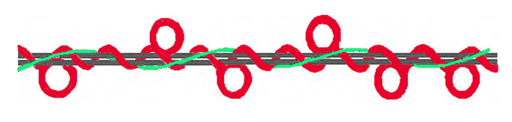
Figure 6 : Structure of Loop Yarn

Snarl Yarn
Like the loop yarn, the snarl yarn has twisted core, although, again for the sake of simplicity, the core has been shown in Figure 7 as two parallel bars. A snarl yarn is one which displays ‘snarls’ or ‘twists’ projecting from the core. It is produced by similar method to the loop yarn, but uses a lively, high twist yarn and a somewhat greater degree of overfeed as the effect yarn.
The required size and frequency of the snarls may be obtained by careful control of the details of overfeed and spinning tension, and by the level of twist in the effect yarn.
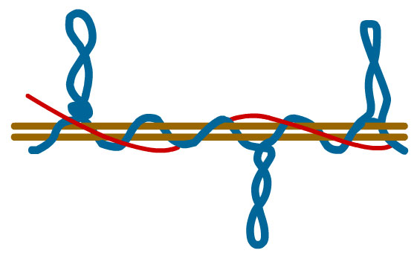
Figure 7 : Structure of Snarl Yarn

Knop Yarn
A knop yarn is one that contains prominent bunches of one or more of its component threads, arranged at regular or irregular intervals along its length (Figure 8 ).
It is normally produced by using an apparatus that has two pairs of rollers, each capable of being operated independently. This makes it possible to deliver the base threads intermittently, while the knopping threads that create the effect are delivered continuously. The knopping threads join the foundation threads below the knopping bars. The insertion of twist collects the knopping threads into a bunch or knop. The vertical movement of the knopping threads results in formation of a bunch or knop. The vertical movement of the knopping bars decides whether the knop is small and compact or spread out along some length of the yarn.
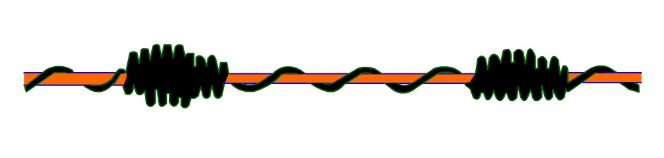
Figure 8 : Structure of Knop Yarn

Slub Yarn
A slub yarn is one in which slubs have been deliberately created to make the desired discontinuity type of effect. Slubs are thick places in the yarn. They can take the form of a very gradual change, with only a slight thickening of the yarn at its thickest point. Alternatively, the slub may be three or four times the thickness of the base yarn, and the increase in thickness may be achieved within a short length of yarn. The yarn pictures in Figure 9 should give a clear impression of the structure of the yarn itself.
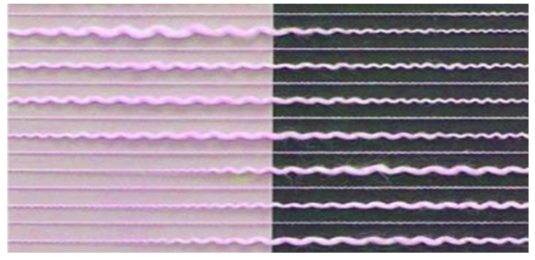
Figure 9 : Structure of Slub Yarn

Fasciated Yarn
A fasciated yarn is a staple fiber yarn that consists of a core of a parallel fibers bound together by wrapper fibers. Yarns made under the airjet spinning method are of this structure. The yarns produced under the hollow spindle method are also frequently described as fasciated, since the binder is applied to an essentially twistless core of parallel fibers.
The fasciated yarn, shown in Figure 10, is produced using the hollow spindle process. It is possible to see the fibers that have escaped and the dark binding thread that contrast with one of the two slivers used as feed-stock in making the yarn.
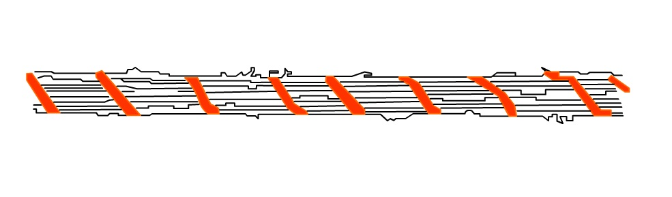
Figure 10 : Structure of Fasciated Yarn

Tape Yarn
Tape yarns may be produced using various processes; braiding, warp knitting and weft knitting being among them (Figure 11). In recent years, these materials have become better known, especially in fashion knitwear. It is also possible to use narrow woven ribbons, or narrow tapes of non-woven material, or slit film, in the same way.
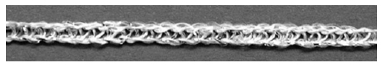
Figure 11 : Structure of Metallic Tricot Tape Yarn
Chainette Yarn
The Chainette yarn, shown in Figure 12, is produced in miniature circular weft knitting process, often using a filament yarn and a ring of between 6 and 20 needles. They have been seen in small quantities for many years, and are being used extensively in fashion knitwear.
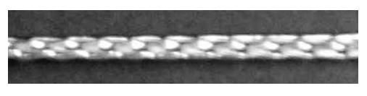
Figure 12 : Structure of Chainette yarn

Chenille Yarn
True chenille yarns are produced from a woven leno fabric’s structure that is slit into narrow, warp-wise strips to serve as yarn. They are pile yarns; the pile length may be uniform throughout the length of the yarn, or it may vary in length to produce a yarn of irregular dimensions. They are used in furnishings and apparel.
Chenille yarns, as shown in Figure 13, have a soft, fuzzy cut pile which is bound to a core. These yarns can be spun, but the machinery required is very specialized. For this reason, these yarns are usually woven on a loom. The effect yarn forms the warp, which is bound by a weft thread. The weft thread is spaced out at a distance of twice the required length of pile. The warp is then cut half way between each weft thread.
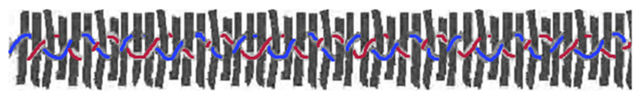
Figure 13 : Structure of Chenille yarn

Ribbon Yarns
These yarns are not produced by spinning. They are finely knitted tubes, pressed flat to resemble ribbon or tape. The ribbons are usually soft, shiny and silky.
Composite Yarns
This yarns also termed as compound yarns as well. It consists of at least two threads, one forming the core of the composite yarn, and the other strand forms the sheath component. Out of the two threads one is staple fiber yarn and other one is filament yarn. It is even in diameter, smooth, and available in the same count range as spun and filament yarns.
Covered Yarns
Covered yarns have a core yarn this is completely covered by fiber or another yarn. Figure 14 shows different types of covered yarns. The core might be an elastomeric yarn, such as rubber or spandex, or yarns, such as polyester or nylon. Covered yarns may have either a single covering or double covering. The second covering is usually twisted in the direction opposite from the first covering.
These yarns are lighter, more resilient, and more economical than double covered yarns and can be used in satin, batiste, broadcloth, and suiting as well as for lightweight foundation garment. Most ordinary elastic yarns are double-covered to give them balance and better coverage. Fabrics made with these yarns are heavier.
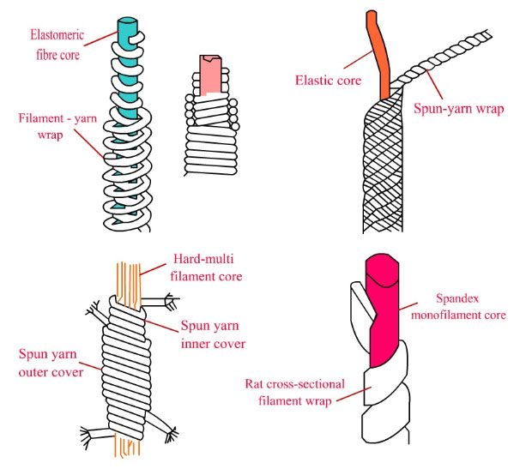
Figure 14 : Different Types of Covered Yarns

Metallic Yarns
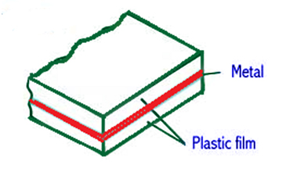
Figure 15 : Cross-section of Lamination used for making Metallic Yarns.

It has been used for thousands of years. The laminating process seals a layer of aluminum between two layers of acetate or polyester film, which is then cut into strips for yarns, as shown in Figure 15. The film may be transparent, so the aluminum foils shows through, or the film and/or the adhesive may be colored before the laminating process. The metallizing process vaporizes the aluminum at high pressure and deposits it on the polyester film.
Sources :
- ‘Fancy yarns: Their manufacture and application’ R H Gong and R M Wright, UMIST, UK, Woodhead Publishing Series.
- ‘Fancy Yarns: Efforts to Methodise, Problems, and New Suggestions’ S. Petrulytė, ISSN 1392–1320 Materials Science (MEDŽIAGOTYRA). Vol. 10, No. 1. 2004
- ‘Technology, Structure and Applications of Fancy Yarns’ Shaikh Tasnim Nisarahmed, International Journal of Engineering Research and Applications (IJERA) ISSN: 2248-9622 www.ijera.com Vol. 2, Issue 3, May-Jun 2012, pp.3109-3117

Copyright IIT Delhi © 2009-2011. All rights reserved.

